Kubernetes – 09
1) Execute all the steps shown in video.
Task Explanation: This task configures Kubernetes Ingress to expose an Nginx web server. An NGINX Ingress Controller will be deployed, followed by the Nginx application and an Ingress.
Step 1: Deploy NGINX Ingress Controller
kubectl apply -f https://raw.githubusercontent.com/kubernetes/ingress-nginx/controller-v1.13.0/deploy/static/provider/cloud/deploy.yaml
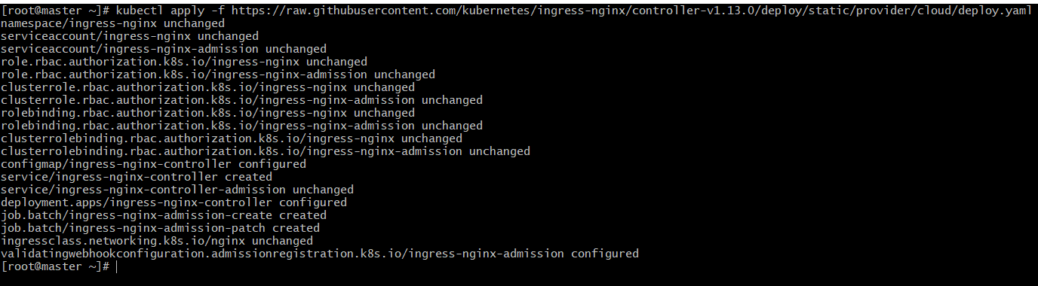
Edit the Ingress Controller service type from LoadBalancer to NodePort:
kubectl edit svc ingress-nginx-controller -n ingress-nginx

Change:
type: LoadBalancer
To:
type: NodePort
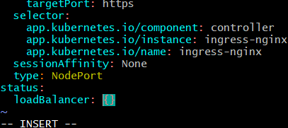

Verify NodePort exposure:
kubectl get svc -n ingress-nginx
Step 2: Deploy Nginx Application Deployment

nginx-deployment.yaml
apiVersion: apps/v1
kind: Deployment
metadata:
name: nginx-deployment
labels:
app: nginx
spec:
replicas: 1
selector:
matchLabels:
app: nginx
template:
metadata:
labels:
app: nginx
spec:
containers:
- name: nginx
image: nginx:latest
ports:
- containerPort: 80
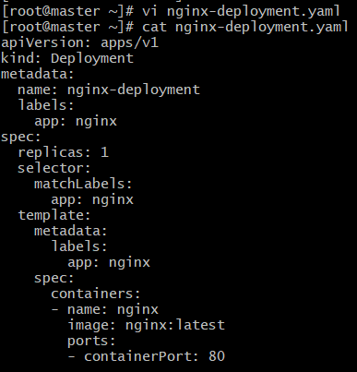
kubectl apply -f nginx-deployment.yaml

Step 3: Deploy Nginx Application Service

nginx-service.yaml
apiVersion: v1
kind: Service
metadata:
name: nginx-service
spec:
selector:
app: nginx
ports:
- protocol: TCP
port: 80
targetPort: 80
type: ClusterIP
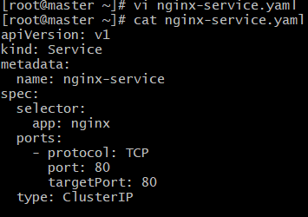
kubectl apply -f nginx-service.yaml
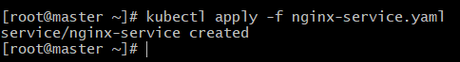
Step 4: Deploy Ingress Resource

nginx-ingress.yaml
apiVersion: networking.k8s.io/v1
kind: Ingress
metadata:
name: nginx-ingress
annotations:
kubernetes.io/ingress.class: nginx
spec:
rules:
- host: syed.mubeen.com
http:
paths:
  - path: /
pathType: Prefix
backend:
service:
name: nginx-service
port:
number: 80

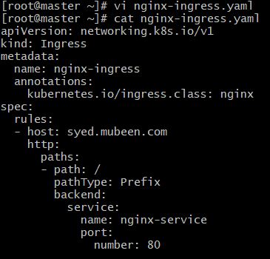
kubectl apply -f nginx-ingress.yaml
Step 5: DNS Configuration
Added to the local machine hosts.
54.164.223.112 syed.mubeen.com
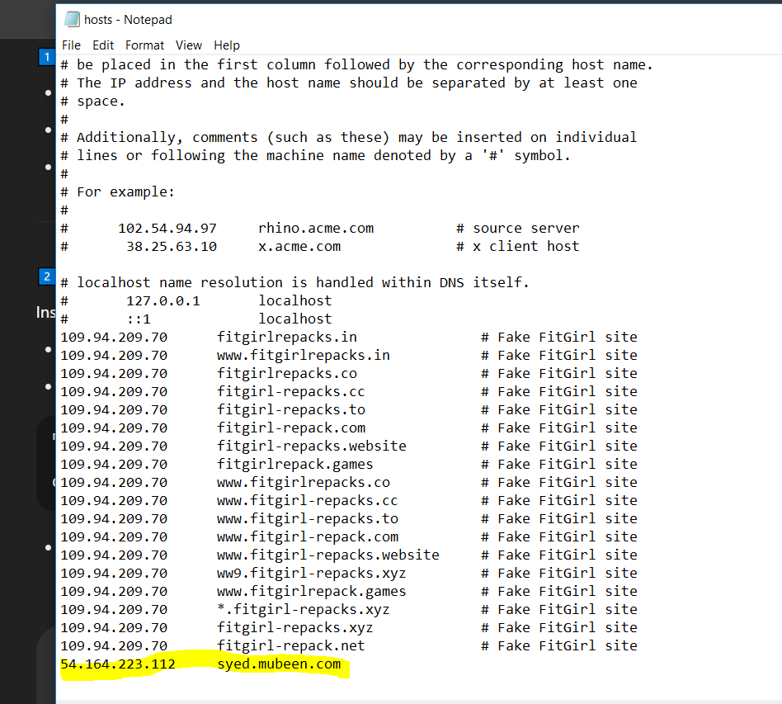

Step 6: Test Access
Use worker-01 public IP.
curl -H "Host: syed.mubeen.com" http://<EC2 Public IP>:32377
curl -H "Host: syed.mubeen.com" http://54.164.223.112:32377
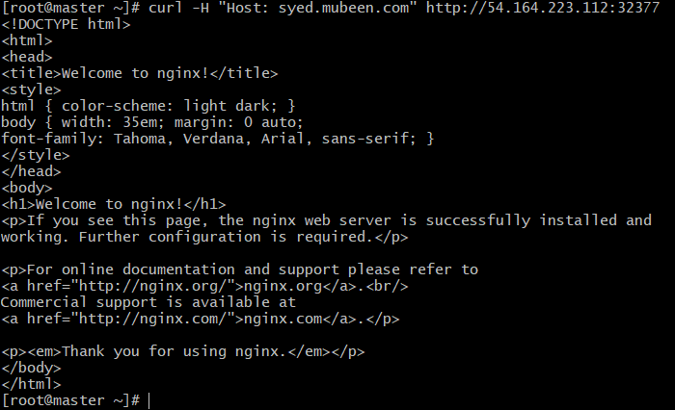
Or open your browser:
http://syed.mubeen.com:32377
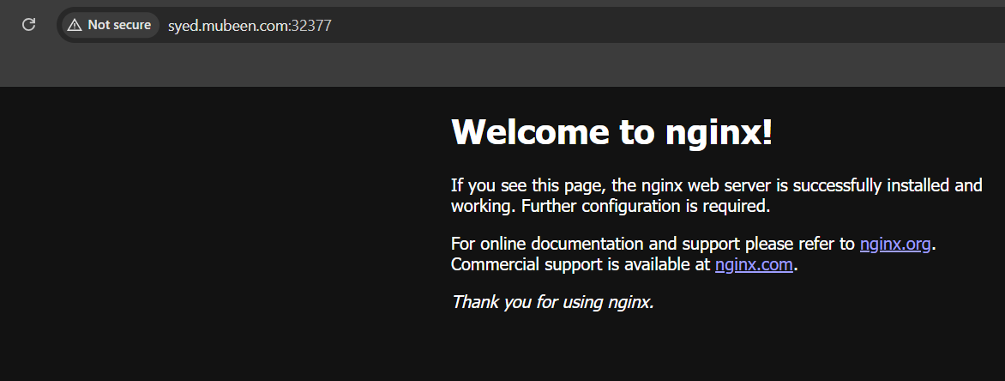
Purpose of this task: This setup provides a public endpoint for your application via NodePort Ingress. It enables path-based routing and allows access using a fake domain through /etc/hosts without needing a real domain. It avoids the need for multiple LoadBalancer services for different applications.

2) Upgrade k8s cluster from 1.26 to 1.28 Version.

Upgraded Kubernetes from v1.30.2 to v1.31.3 (client, kubelet, kubeadm) and from v1.30.14 to v1.31.3 (server) on CentOS 7.

Validation Before Kubernetes Upgrade
kubectl get nodes
kubectl version --short
kubeadm version
kubelet –version

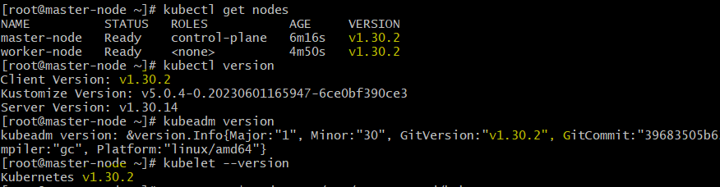
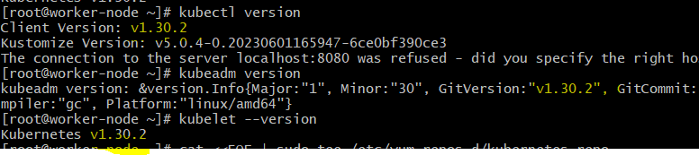

Upgrade Kubernetes to v1.31

1️⃣ Update Repo to v1.31
cat <<EOF | sudo tee /etc/yum.repos.d/kubernetes.repo
[kubernetes]
name=Kubernetes
baseurl=https://pkgs.k8s.io/core:/stable:/v1.31/rpm/
enabled=1
gpgcheck=1
repo_gpgcheck=1
gpgkey=https://pkgs.k8s.io/core:/stable:/v1.31/rpm/repodata/repomd.xml.key
EOF

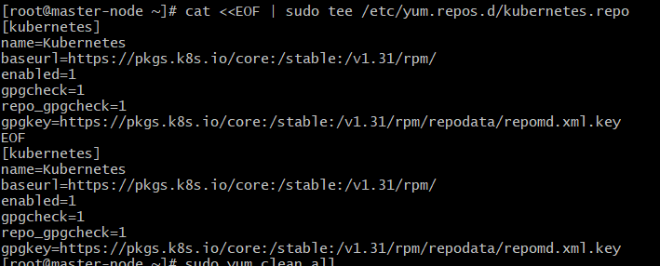
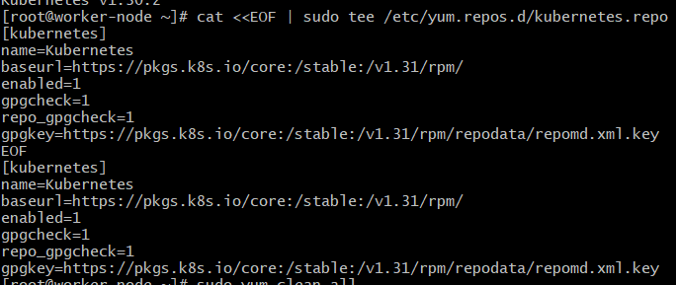

2️⃣ Clean Cache & Refresh
sudo yum clean all
sudo yum makecache –refresh

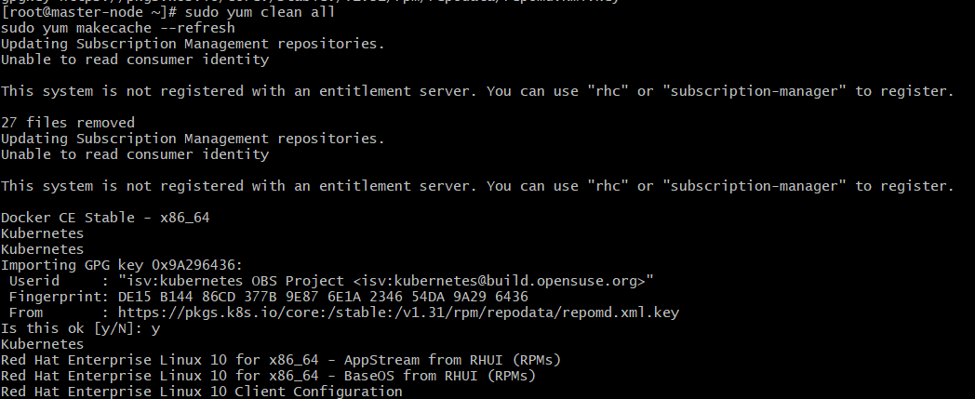
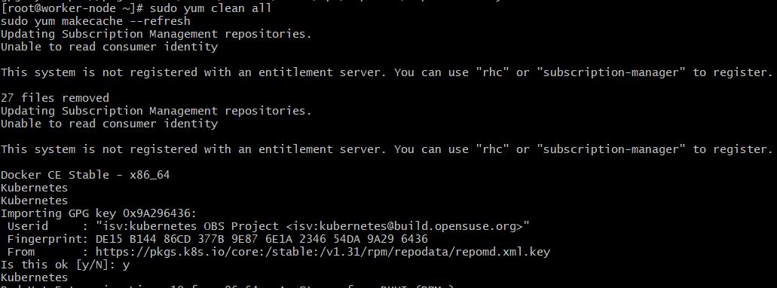

3️⃣ Install Kubernetes v1.31 Components
sudo yum install -y kubeadm-1.31.3 kubelet-1.31.3 kubectl-1.31.3
sudo systemctl daemon-reexec
sudo systemctl restart kubelet

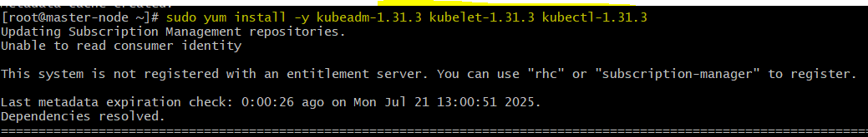
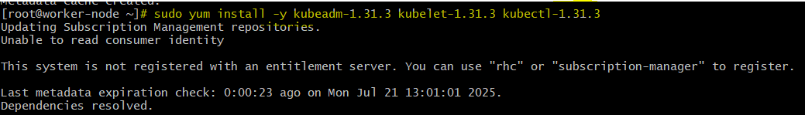

4️⃣ Upgrade Control Plane (On Master)
sudo kubeadm upgrade plan
sudo kubeadm upgrade apply v1.31.3

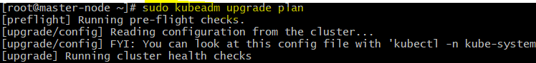

5️⃣ Upgrade Kubelet on Worker Nodes (Already Installed Step 3)
No additional action needed other than restart:
sudo systemctl daemon-reexec
sudo systemctl restart kubelet

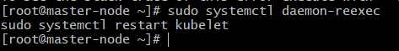

🔷 Validation After Upgrade to v1.31
kubectl get nodes
kubectl version
kubeadm version
kubelet --version

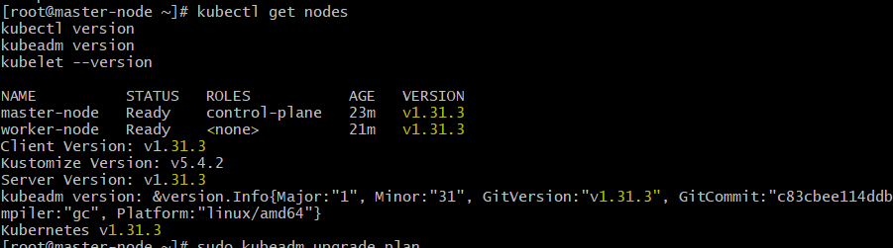
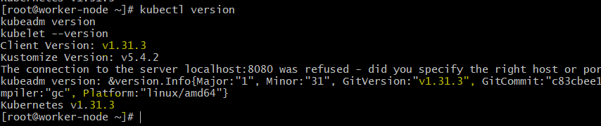

THE-END

